Task: Basic Linux Commands

Objective
Perform basic operations and run basic commands on the Linux system using TryHackMe.

Questions & Answers
Q1: What command shows the current directory?
Answer: pwd — Prints the current working directory. Output: /home/student

Q2: What is the username you are logged in as?
Answer: student — Obtained using the whoami command.

Commands Used
Command | Description & Output
pwd | Print Working Directory → /home/student
whoami | Show logged-in username → student

Screenshot of Command Output
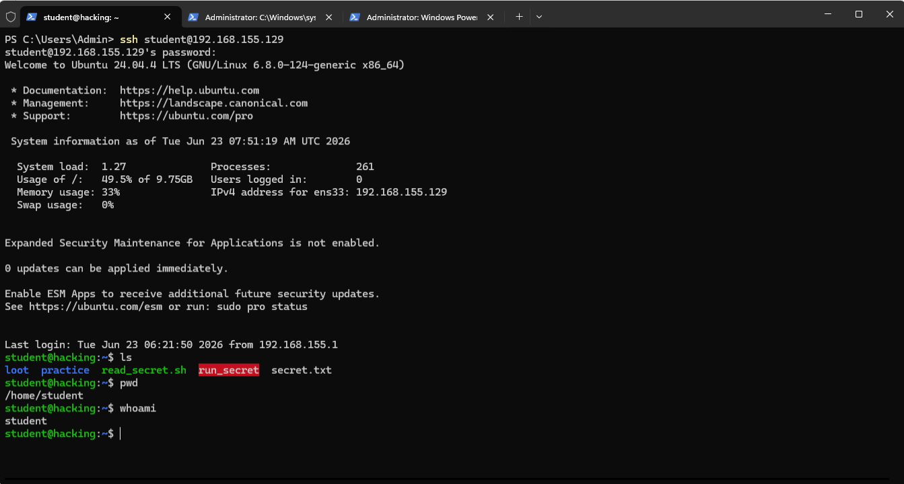
Figure 1: pwd and whoami commands executed on Ubuntu 24.04 LTS via SSH

Environment Details
- Platform: TryHackMe (tutedude-cybersec room)
- OS: Ubuntu 24.04.4 LTS (GNU/Linux 6.8.0-124-generic x86_64)
- Target IP: 192.168.155.129
- Username: student
- Access Method: SSH via PowerShell

